RAY EASTER
Comedian • Writer • Actor
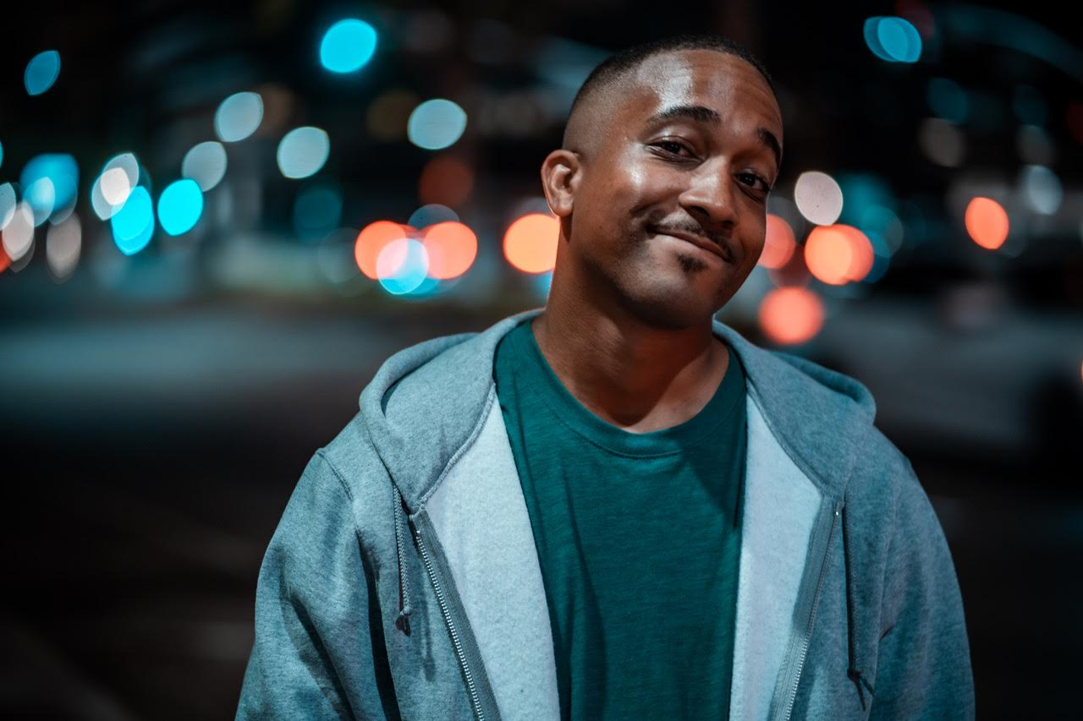
www.RayEaster.com
rayeaster.comedy@gmail.com

Management
Lee Mayer - Houla Entertainment
Leemayer@houlaentertainment.com

Stand Up Videos
https://youtu.be/PBbpwX4mUSo
https://youtu.be/hYwvWfybXO0

IMDb
https://m.imdb.com/name/nm9167556/

Bio
Ray Easter has performed in cities across the country from New York to Los Angeles, bringing his smart, witty comedy to bars, colleges, and clubs along the way. His relatable, accessible comedy appeals to a wide array of audiences providing him with consistent on-stage success. Ray will also be featured on season 2 of Laugh After Dark on Amazon Prime.

​Raised a military brat, Ray was born in Syracuse, NY, and spent his teen years in the D.C. metro area. After wrapping up college at Virginia State University, he started performing in 2012. From an early age, Ray was inspired by the observational style of comedy greats like Dave Chappelle, Chris Rock, Bill Burr, and Jerry Seinfeld. Today, he is proud to have worked with prominent comics such as Tony Woods, Eddie Pepitone, Ruben Paul, and Adam Ray.

Clubs Worked
Wiseguys Comedy Club, Las Vegas, NV
House of Comedy, Phoenix, AZ
Fort Wayne Comedy Club, Ft. Wayne, IN
Laughs Unlimited, Sacramento, CA
Loonies Comedy Bin, Colorado Springs, CO
The Setup, San Francisco, CA
The Joke Joint, Houston, TX
The Comedy Store, Los Angeles, CA
Laugh Factory, Los Angeles, CA
The Dojo of Comedy, LA
Westside Comedy Theatre, Los Angeles, CA
The Idiot Box Comedy Club, Greensboro, NC
LA Comedy Club, Las Vegas, NV
Mad House Comedy Club, San Diego, CA
Comedy Heights, San Diego, CA
The SetUp, San Francisco, CA
Harvey’s Comedy Club, Portland, OR
Dangerfield’s Comedy Club, NYC
The Laughing Skull, Atlanta, GA
TakeOut Comedy Club, Central, Hong Kong
The Ice House Comedy Club, Pasadena, CA
Ha Ha Café, North Hollywood, CA
Van Nuys Comedy Club, Van Nuys, CA
Flappers Comedy Club, Burbank, CA
New York Comedy Club, NYC
Stand Up NY, NYC
Eastville Comedy Club, NYC
Cozzy’s Comedy Club, Newport News, VA
Richmond Funny Bone, Richmond, VA
Broadway Comedy Club, NYC
Greenwich Village Comedy Club, NYC
DC Comedy Drafthouse, Washington DC
Arlington Cinema Drafthouse, Arlington, VA
Riot Act Comedy Theatre, Washington DC

Theatres Worked
Skiptown Playhouse, LA
Billy Webb Elks Lodge, Portland, OR
Pack Theater, LA
LA Connection, North Hollywood, CA
The Clubhouse, LA
Impro Studio, LA
Elephant Nature Park, Chiangmai, Thailand
Fountain Theater, LA
Bright Box Theater, Winchester, VA
Howard Theatre, Washington DC
Coalition Theater, Richmond, VA
Jammin’ Java, Vienna, VA

Notable Events
Rubee Tuesdays
Chocolate Sundaes
The Show Unbeatable
Trailer Trash Talent Revue
COMMITTED: A Comedy Show For Charity
You Don’t Know Me Yet Comedy Show
Speakeasy Comedy
Kill Tony Podcast: Episode #220
Dave McNary’s All-Star Variety Show
Uncle Clyde’s Comedy Contest

Comedy Festivals
2021 World Series of Comedy, Las Vegas, NV
2019 Burbank Comedy Festival, Burbank, CA
2019 World Series of Comedy, Las Vegas, NV
2019 North Carolina Comedy Festival, Greensboro, NC
2018 NW Black Comedy Festival, Portland, OR
2017 Bird City Comedy Festival, Phoenix, AZ
2017 360 Comedy Festival, NYC
2017 Glendale Comedy Festival, Glendale, CA

Film
Laugh After Dark/Himself/Dir. Kelsey Borlan Lee
Oprah For President/Stedman/Dir. James Claybrooks
The Adventures of Ugg Boot Man/Ugg Boot Man/Dir. James Claybrooks
Continue 9, 8, 7…/Gamer Customer/Dir. Lucas Culshaw
The Popular Outcasts/Various Roles/Dir. Pete Buchbauer
The Popular Outcasts Live!/Various Roles/Dir. Pete Buchbauer

